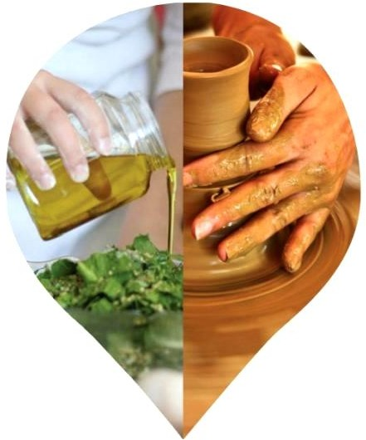

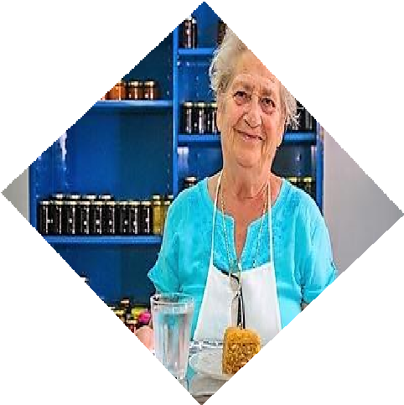
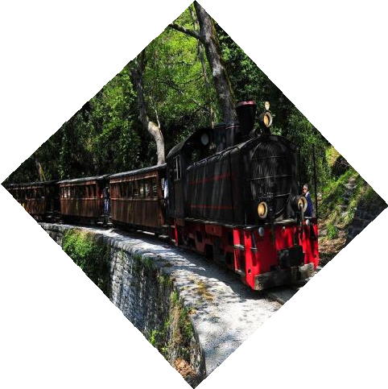
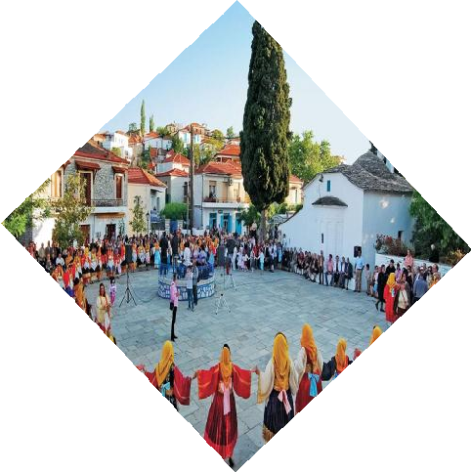
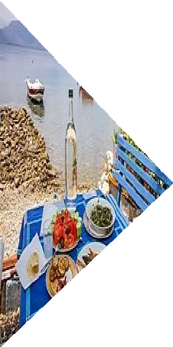
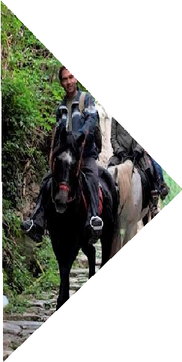
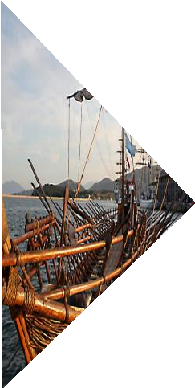

Live Like Local is a brand new and innovative destination management platform, which provides unique experiences by inducting you to the real world of the locals and the local lifestyle.
LLL is founded on the principles of sustainable and experiential tourism. Our cultural legacy, as it’s inherent in every single moment of the modern
lifestyle, is the core of LLL and the key characteristic of this entire project.

We invite you to feel our region’s vibrant character, live it, experience how tradition and mythology revive nowadays and
become part of it.

The project is implemented in the Magnesia regional state, at the heart of Greece. More specifically, it is running in the city of Volos, Mount Pelion and its coastal area. The timeless character of the area as a destination
and its multifaceted presence in cultural events from ancient times until today are the elements that make it an ideal,
memorable travel destination choice. It is guaranteed that Magnesia will magnetize you!

We have recorded the offered infrastructure of the area and we developed ones, where was needed, with the cooperation
of the “crème de la crème” of local professionals, authorities and operators, in order to create and offer reliable, organized and competitive
themed trips for your acquaintance with the authentic Greek soul.

We unified the “puzzle” of our region and deliver it in a functional, as well as, simplified way. What makes Live Like Local so unique, is that this project stems from the deep knowledge of the local scenery, the pure love and respect for the motherland and the high sense of responsibility for this whole venture that only the locals can guarantee. We invite you to join us and live like the locals do!
The whole project is presented step by step in the subsequent eight categories. We have gathered updated and accurate information about the area, in order for you to live this unique experience with us!

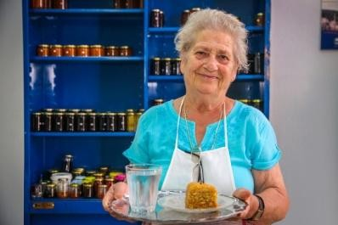
Ask a local
The key-category containing the specific profile of each region, with reliable, updated information and tips so that you can navigate freely with safety. We have the answer to all your questions about the area, before you even think of them.
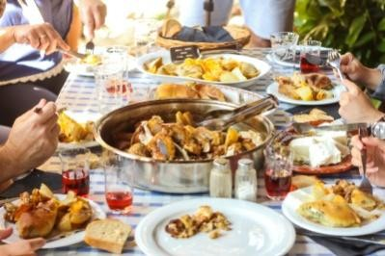
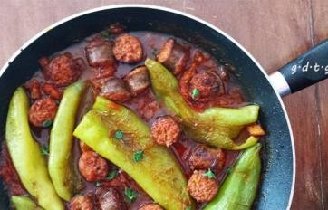
Local flavors
In a place, like Magnesia, where both sea and the mountain set the scenery, food is more than tasteful. The organic farms and the unique microclimate of the area offer crop in almost every season. Fruits and vegetables are matched perfectly with meat, fish and other sea fruits satisfying even the most demanding palates. In this category, we present the most characteristic traditional recipes. Bring your appetite in hands – on cooking classes and let the housewife indulge you to the Greek iconic dishes.

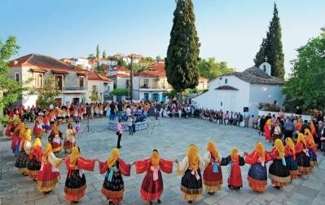
Calendar
The revival of the legacy in modern times is taking place through local festivities and events that are held in various places and times during the year. You have the choice either to join them or take a leading role, like the locals do, by dancing traditional dances and wearing traditional costumes.

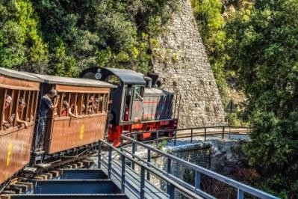
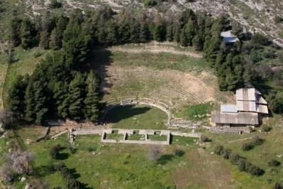
Sightseeing
In Sightseeing you can find suggestions for discovering the local area through visiting official sites, such as churches, museums, monuments and archaeological sites. These are only some of our proposals to initiate you to the local history and tradition. Moreover, the natural wealth of the area offers you a great variety of spots that you should visit in order to capture the local vibes. Here, you can also find suggestions for places to visit and tips that will make easier reaching them.

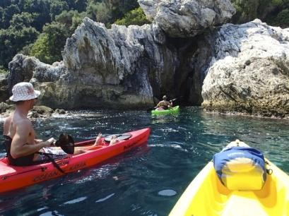
Activities
The majesty of the place derives from the combination of sea and mountain. The best recipe for your acquaintance with our region is to participate in various activities either under the sea or on the slopes of the mountains. All of these activities under the instructions of well trained and certified training professional tutors. We suggest, you choose.
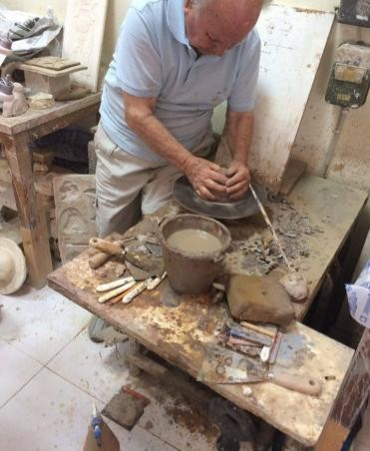
Creative
We offer you the opportunity for a cultural exchange that goes well beyond a visit to popular tourist sights. This is succeeded by getting involved in cultural workshops based on the legacy of the region and locals’ authenticity and generosity, two core values of the Greek lifestyle. You will have the chance to get immersed with all your senses to the Greek culture and tradition, by taking advantage of natural, cultural and human resources. The pivotal aspect of these workshops is that they are designed and implemented by showing total respect for the locals and their environment.

Local Products
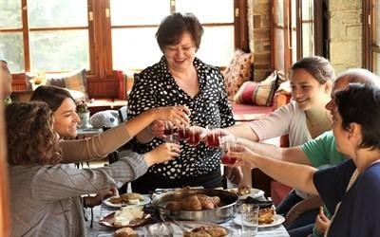
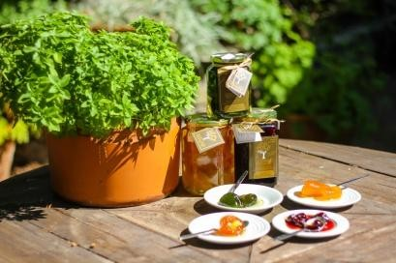
In a place that three out of four seasons, nature gives crop, you can imagine the variety of fruits, vegetables and nuts flourishing on the slopes of Pelion Mountain. Having these as basic materials, a great variety of local products are offered. Even in the same season you can have different crops in different places. Indicatively, you can find more than 1500 herbs that thrive exclusively in the mountain.
Live Like Local
We invite you to live your own myth in the legendary Pelion Mountain and indulge in the local lifestyle and Greek hospitality. Themed trips are especially designed to offer to you unique and authentic experiences. We have gathered all the worthy of admiration hints mentioned in the above categories and we have harmonically blended them together. During your trip you will have as fellow - travelers the locals, who are willing to share with you the secrets of the Greek, local lifestyle. We are happy to customize or even design from the beginning trips according to your interests and needs.

Our trademark is registered and consists intellectual property of our company.

For your detailed information, please visit our brand new website.

www.livelikelocal.gr

Glavani 36a, Volos, 38221, Greece +30 2421033662
info@livelikelocal.gr

